**Rabanes, Matthew Gabriel M.**

**Tenedero, Gerard Emilson G.**

**Problem 2:** Write a program that accepts as input three points (𝑥, 𝑦) lying on a circle in a 2- dimensional Cartesian plane. The program must return the following parameters of the circle on which the three points lie:

* center (ℎ, 𝑘);
* radius 𝑟;
* vector [𝐷, 𝐸, 𝐹], where 𝐷, 𝐸, and 𝐹 are the coefficients in the general equation of a circle 𝑥^2 + 𝑦^2 + 𝐷𝑥 + 𝐸𝑦 + 𝐹 = 0;

**Code Screenshot:**

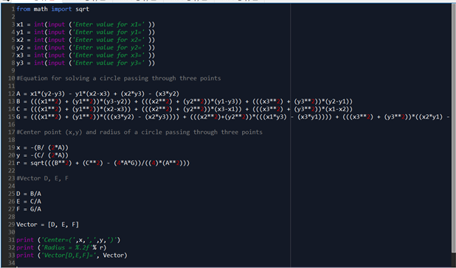

**Sample:**

Values of the three points of a circle are (7,4), (-3,2), and (8,-1)

